**Deliverable One**

DEPARTMENT OF MECHANICAL ENGINEERING

Machine Design ME 643

Group 20

*Reed Bell*

*Zhangxi Feng*

*Sydney Michalak*

*Simon Popecki*

*James Skinner*

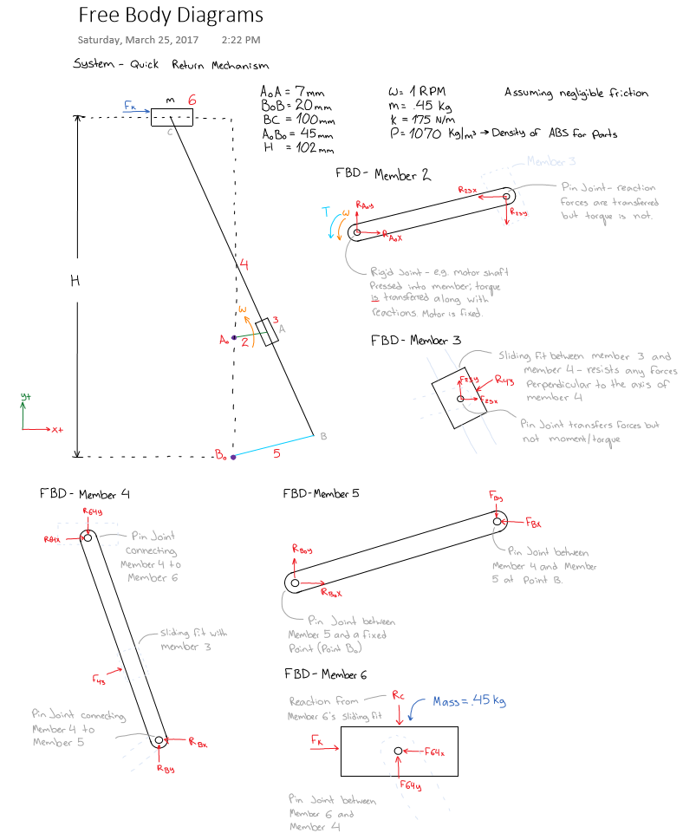

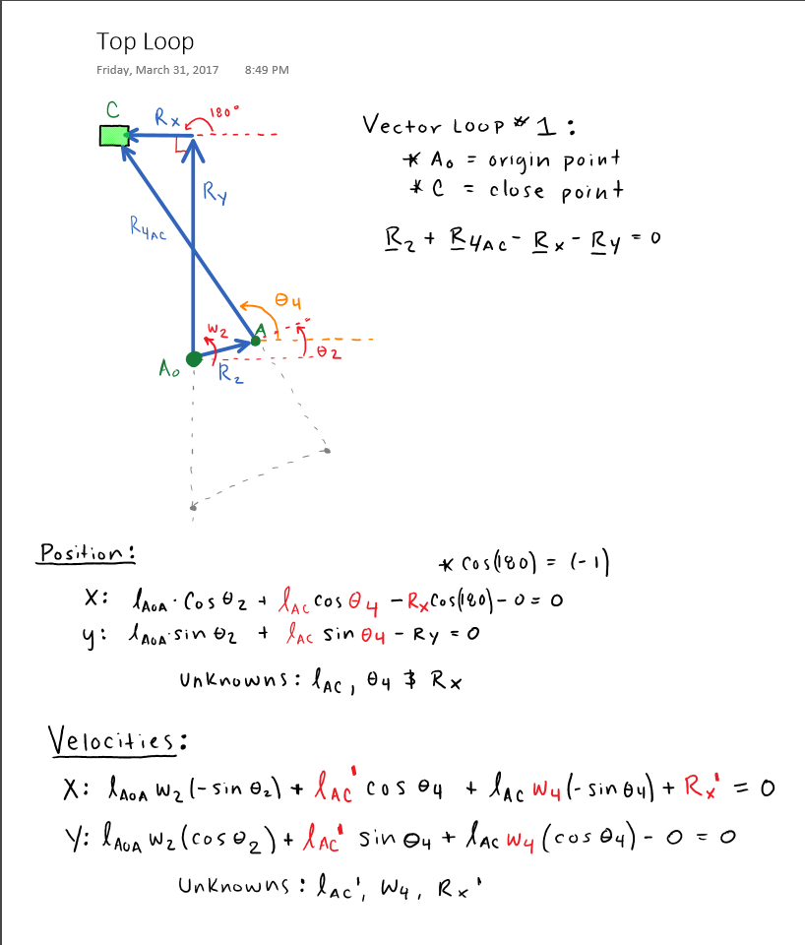

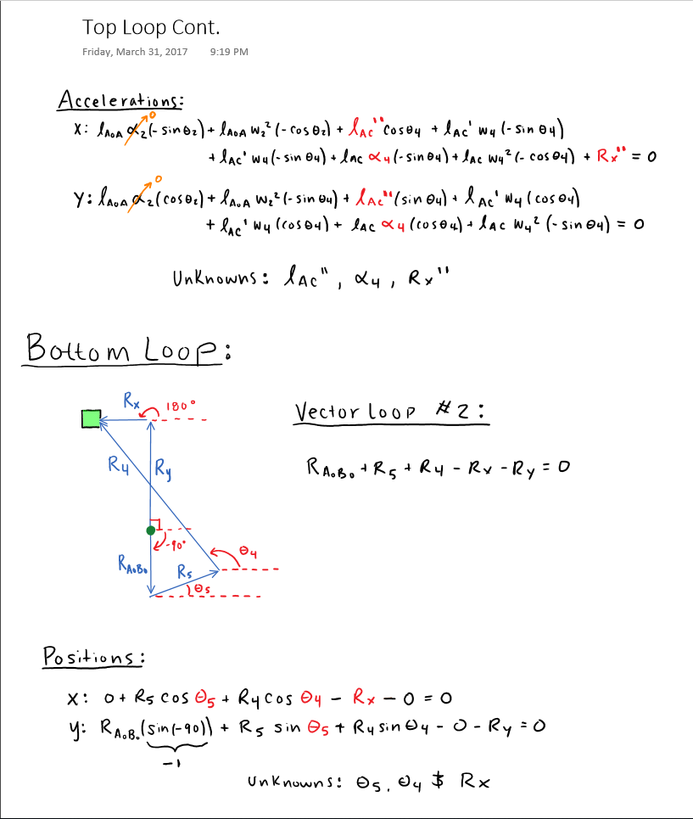

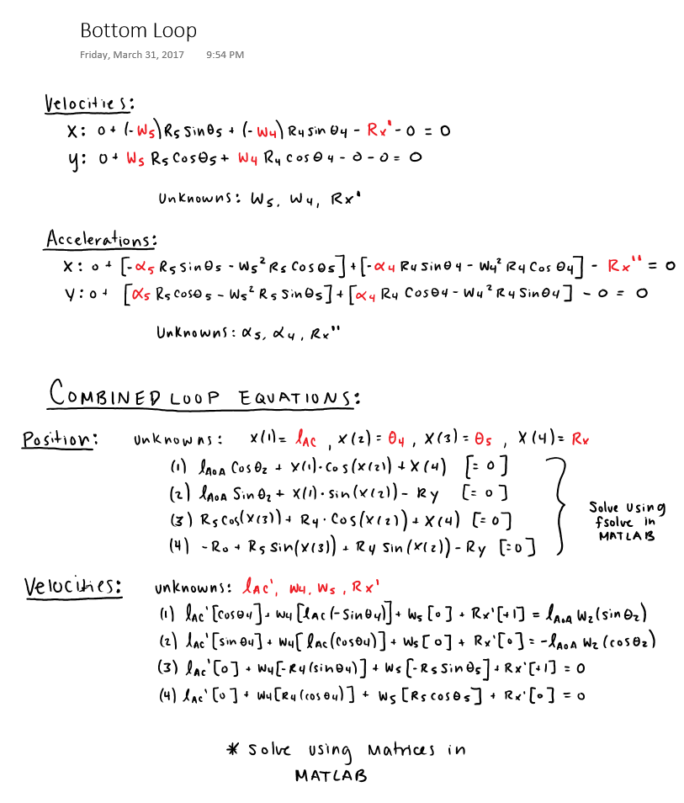

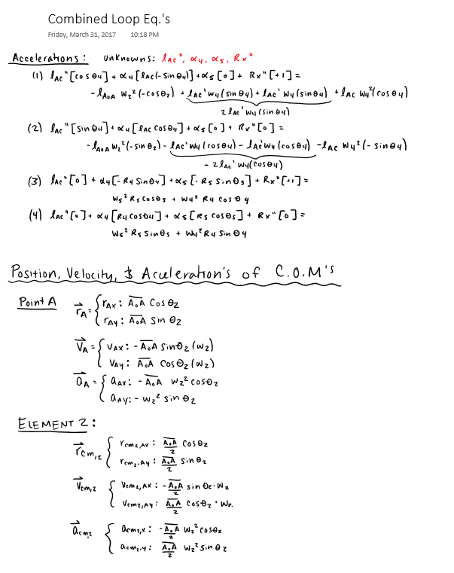

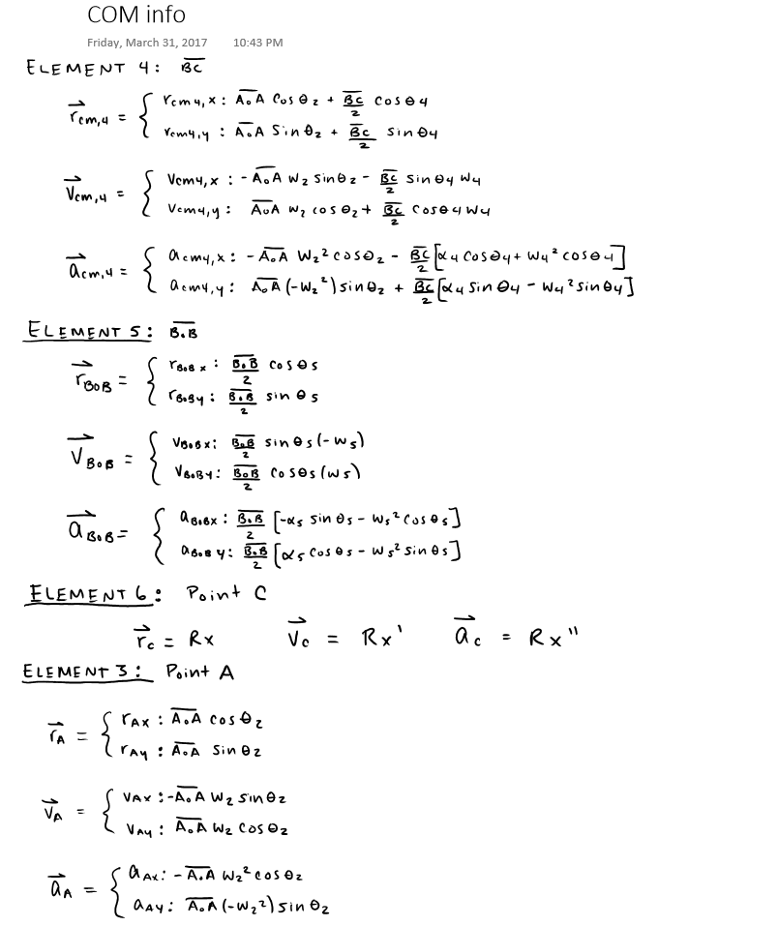



Figure 1 - Graph 1



Figure 2 - Graph 2



Figure 3 - Graph 3



Figure 4 - Graph 4

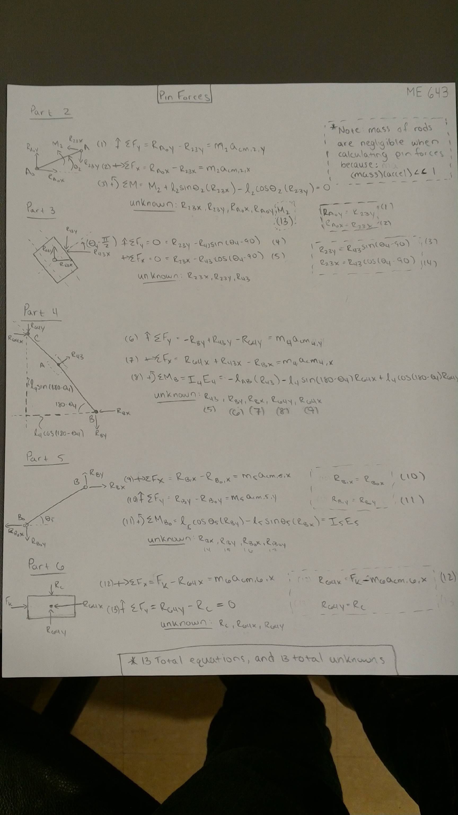



Figure 5 - Graph 5

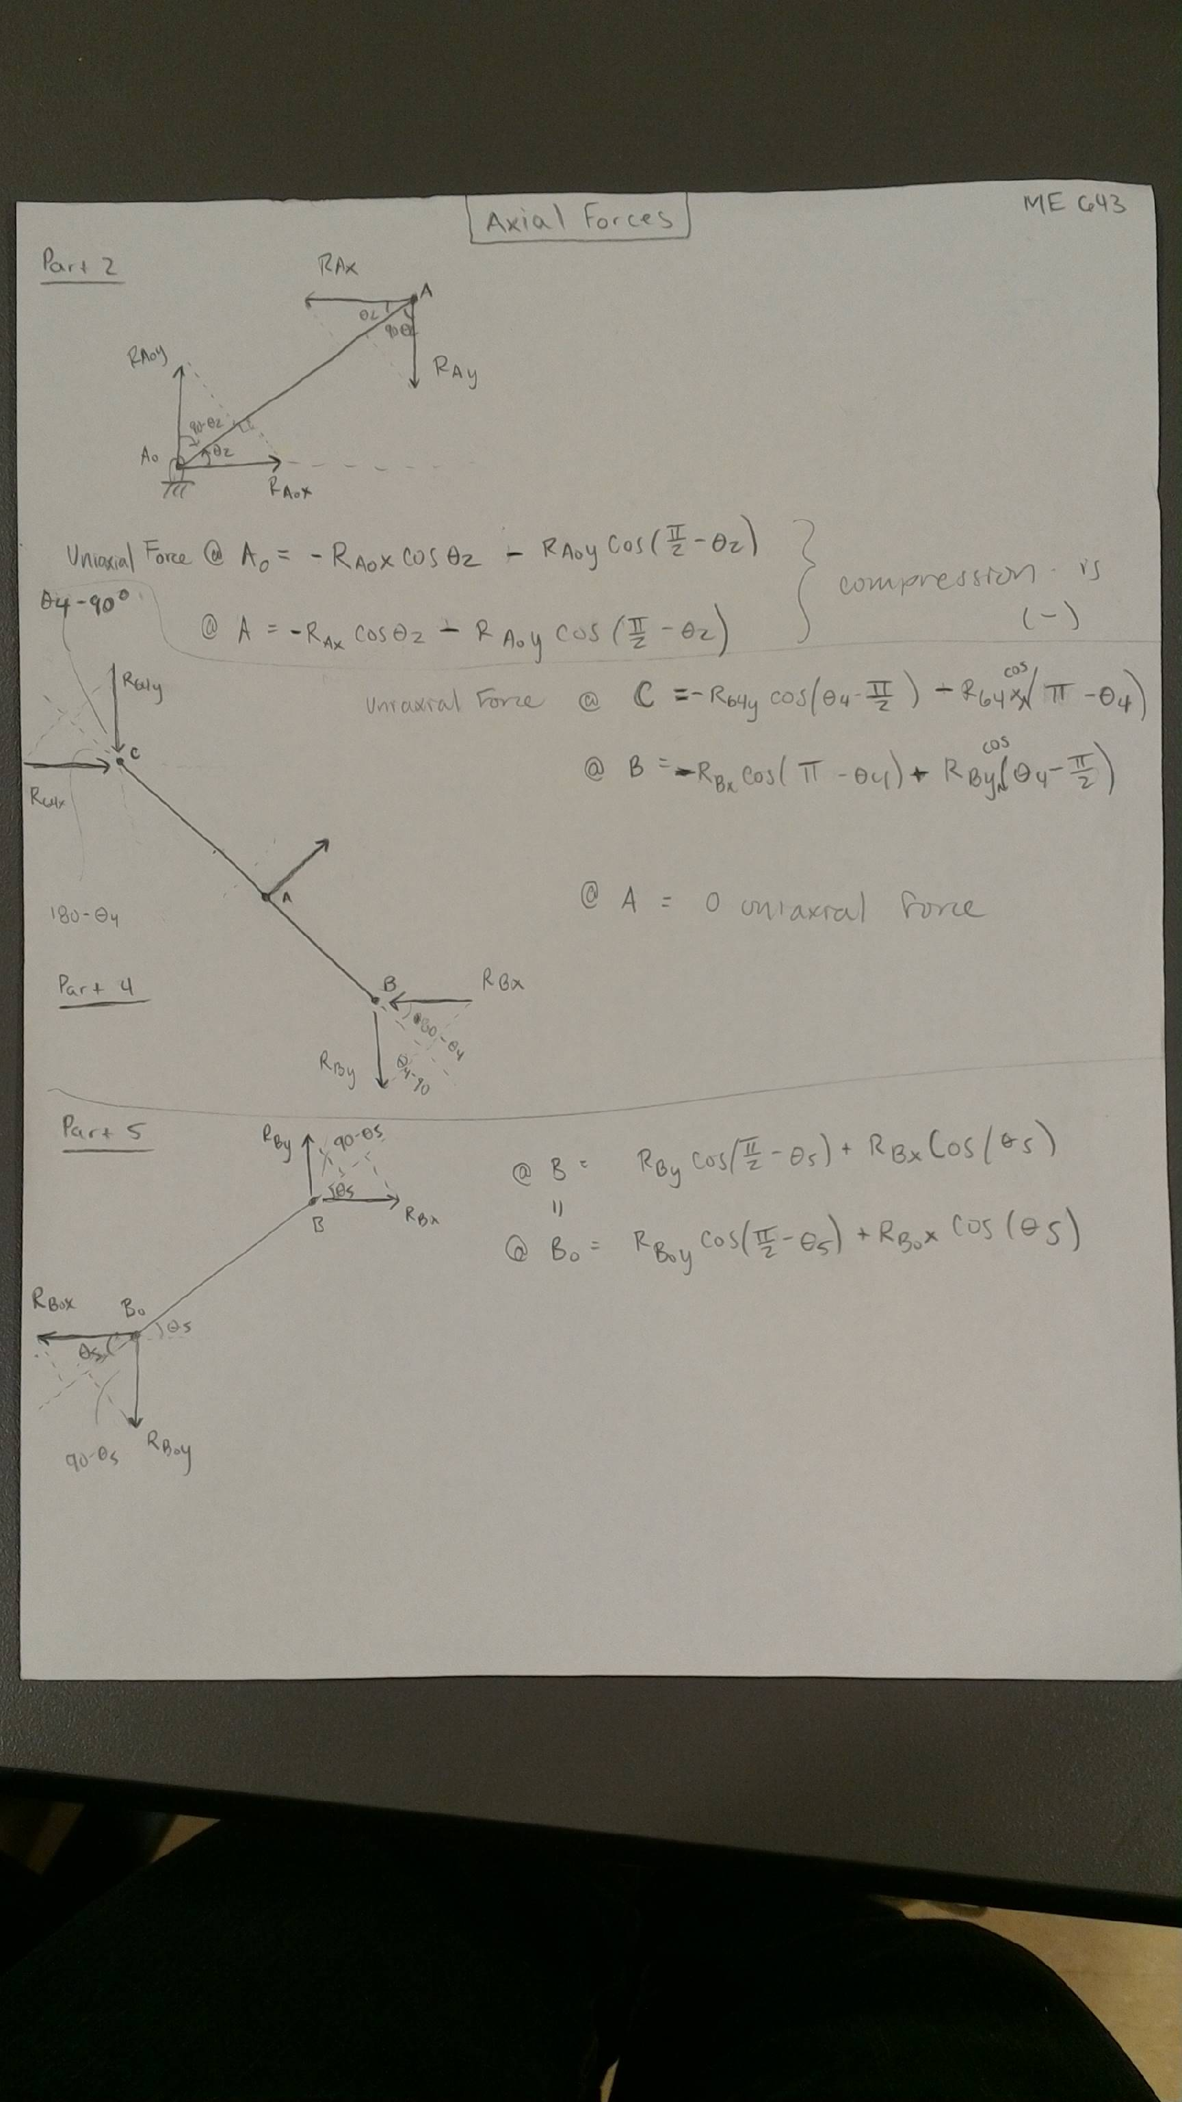

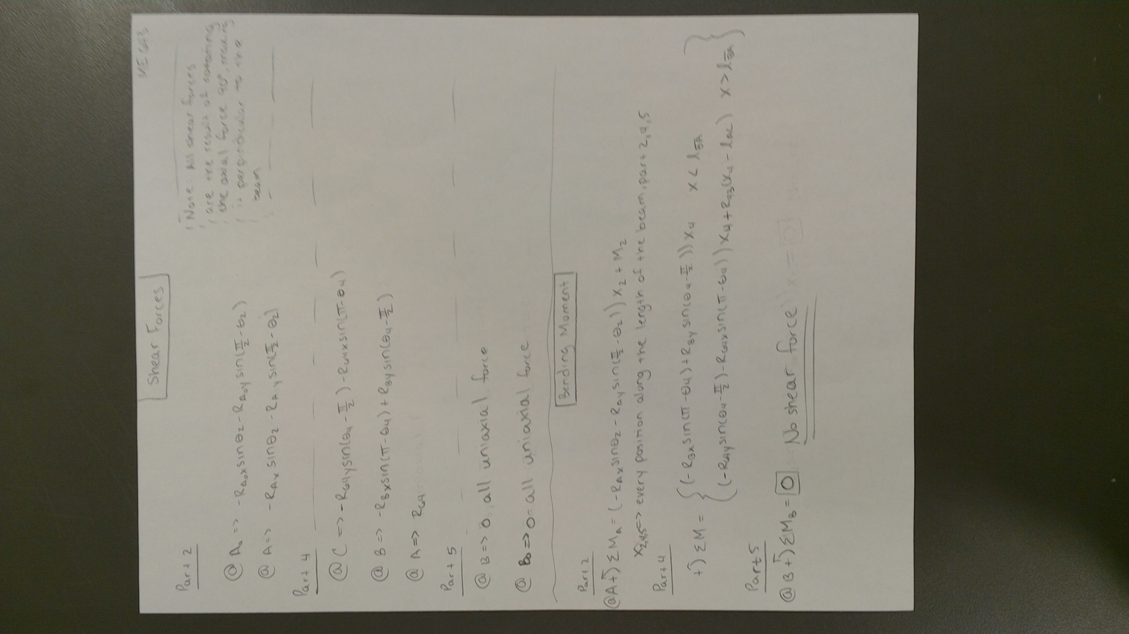



Figure 6 - Graph 6



Figure 7 - Graph 7



Figure 8 - Graph 8



Figure 9 - Graph 9



Figure 10 - Graph 10



Figure 11 - Graph 11



Figure 12 - Graph 12



Figure 13 - Graph 13. This graph did not represent what we expected after analyzing this member. We expect the bending moment to be zero at both ends of the beam. The profile of the bending moment along the beam, at any given theta, should be linear, increasing from zero and then decreasing back to zero, or vice versa.



Figure 14 - Graph 14

|  |  |  |  |
| --- | --- | --- | --- |
| **Member** | **Min Axial Force** | **Min Shear Stress** | **Min Bending Moment** |
| 2 | -6.88 N | 23.95 N | 141.92 N-mm |
| 4 | -9.72 N | -24.84 N | -1547.70 N-mm** |
| 5 | -20.11 N | 0 N | 0 N-mm |

** This value is potentially incorrect.

|  |  |  |  |
| --- | --- | --- | --- |
| **Member** | **Max Axial Force** | **Max Shear Stress** | **Max Bending Moment** |
| 2 | 23.95 N | 6.88 N | 104.26 N-mm |
| 4 | 0.02 N | 5.1 N | 201.41 N-mm |
| 5 | 0.59 N | 0 N | 0 N-mm |

**\*All Required code attached in email.**